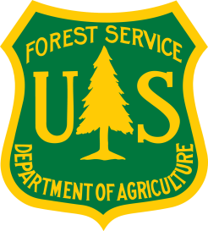
First Friday All Climate Change Talks (FFACCTs)
Hosted by the USDA Forest Service Eastern Forest Environmental Threat Assessment Center

Agenda
Date: Friday, September 1, 2017
Time: 11:00 a.m. to 12:30 p.m. (eastern)
Audience: Forest Service internal and external partners and stakeholders, non-governmental organizations, universities, customers, and other interested individuals
Connection Information: Please connect 5 minutes prior to the start of the forum.
- Join the Adobe Connect web meeting: https://usfs.adobeconnect.com/ffacct-500/
[Select “Enter as a Guest,” enter your name, and click “Enter Room.”]
- Dial (888) 844-9904, and enter passcode 9066591# to access audio.

Welcome and Introductory Comments
Joel Larson, Acting Director, USDA Southeast Regional Climate Hub

Washington Office Update
Karen Dante, Climate Change Adaptation and Policy Specialist, Office of Sustainability and Climate Change

Climate Science Center Updates
Toni Lyn Morelli, Research Ecologist, Northeast Climate Science Center & University of Massachusetts
Ryan Boyles, Director, Southeast Climate Science Center

Station, Region, and Hub Updates
Rachel Steele, National Coordinator, USDA Climate Hubs
Dave Hollinger, Director, USDA Northeast Climate Hub
Leslie Brandt, Climate Change Specialist (Northern Institute of Applied Climate Science), Eastern Region
Emrys Treasure, Regional Inventory, Monitoring, and Assessment Coordinator, Southern Region
Michael Gavazzi, Biological Scientist, USDA Southeast Regional Climate Hub
William Gould, Research Ecologist, International Institute of Tropical Forestry, and Director, USDA Caribbean Climate Hub
Presentation*
“Proof that some, but not all wildland fires increase surface water supply.” – Dennis Hallema, Research Fellow, Oak Ridge Institute for Science and Education (USDOE)

Round Robin

Final Comments

